**TCGF 2024 SCHEDULE**

**3/24/24 revision**

|  |
| --- |
| **6u** *pitching distance* ***3*5’** |
| 1 LARSON |
| 2 KEEFE |
| 3 MOON |
| 4 STEENBEKE |
| 5 STOUT |
| 6 PAIS |

|  |
| --- |
| **8u** *pitching distance* ***3*5’** |
| 7 HIGGINBOTHAM |
| 8 SPARKS |
| 9 KEEFE |
| 10 RADANOVICH |
| 11 PERRY |

|  |
| --- |
| **12u**  *pitching distance* **40’** |
| 18 ROBERSON |
| 19 SPARKS |
| 20 SERRANO |
| 21 SMITH |
| 22 PERRY |
| **14u**  *pitching distance***43’** |
| 23 SPARKS |
| 24 DAVIS |
| 25 HEWITT |
| 26 WILSON |

|  |
| --- |
| **10u**  *pitching distance* **35’** |
| 12 HYSKE |
| 13 ROBERSON |
| 14 OLSON |
| 15 WARNICK |
| 16 BOATRIGHT |
| 17 HELDSTAB |

**GAME DAY ETIQUETTE**

**ALL GAMES HAVE A TIMELIMIT. GAMES WILL NOT EXCEED THE MAX TIME LIMIT.**

**Innings may start prior to the max time, but shall be discontinued once the max time limit is reached regardless of if a batter is in the middle of an at bat. This must be strictly adhered to in order to in order to allow for all teams/games an equal amount of play time.**

**Since this is a developmental league, use as much time as possible, even if you can only complete a partial inning. For scoring purposes, the final score will revert back to the last full inning of play completed.**

**READING THE SCHEDULE**

**HOME vs AWAY**

**If the schedule says 14 v 17, Team 17 is the HOME team. The Home team is listed Second**

**If the schedule says 18 @ AMA, Team 18 will play against AMA softball @ Copello Field in Angels Camp. Copello Field rules**

**may vary. @ Mariposa, the game is at Mariposa County High School. Please be flexible and respectful of their respective fields.**

**Home team**

**Use 3rd base line dugout**

**Infield warmups 15 min. before game start time (Only home pitcher can use mound at this time)**

**Visiting team**

**Use 1st base dugout**

**infield warmups 30 min. before game start time (Only visiting pitcher can use mound at this time)**

**Out of play areas (between fields) are recommended for warmups while games are concluding and being tended to. Stay off the infield for the**

**15 minutes during the other team’s infield warmups utilizing the outfield and out of play areas for batting, fielding and**

**pitching.**

**Note: Infield warmups are subject to temporary closure for watering, chalking lines, and moving mounds**

**OPENING DAY 3/16/24**

**PICTURES 3/16/24 @ STANDARD PARK**

**18500 Standard Rd. Sonora Ca. 95370**

|  |  |  |  |  |  |  |  |
| --- | --- | --- | --- | --- | --- | --- | --- |
| **7:00a** | 26 | **8:45** | 5 | **10:30** | 23 | **12:15** | 22 |
| **7:15** | 25 | **9:00** | 7 | **10:45** | 24 | **12:30** | 20 |
| **7:30** | 1 | **9:15** | 8 | **11:00** | 10 | **12:45** | 18 |
| **7:45** | 2 | **9:30** | 11 | **11:15** | 21 | **1:00** | 15 |
| **8:00** | 3 | **9:45** | 9 | **11:30** | 19 | **1:15p** | 16 |
| **8:15** | 6 | **10:00** | 12 | **11:45** | 17 |  |  |
| **8:30** | 4 | **10:15** | 13 | **12:00** | 14 |  |  |

**Your team should arrive 15 minutes early to pictures to make sure all players are present for the team photo.**

|  |  |  |  |  |
| --- | --- | --- | --- | --- |
| **Field 1** | 8:15-10:30a **14u**  26 v 25 | 11:30-1:45 **14u**  23 v 24 |  | 2:45-5:00p **12u**  22 v 20 |
| **Field 2** | 8:00-09:00a **6u**  1 v 2 | 9:45-11:15a 8**u**  7 v 8 | 12:00-2:15p **12u**  21 v 19 | 2:45-5:00p **12u**  18 v 19 |
| **Field 3** | 8:30-9:30a 6**u**  6 v 3 | 10:15-11:45a 8**u**  11 v 9 | 12:15-2:00p 8**u**  10 v 7 |  |
| **Field 4** | 9:00-10:00a 6**u**  5 v 4 | 10:45-12:30p **10u**  12 v 13 | 1:00-2:45p **10u**  17 v 14 | 3:15-5:00p **10u**  16 v 15 |

**MARCH 18-22**

|  |  |  |  |  |  |  |  |  |  |  |  |  |  |  |  |  |
| --- | --- | --- | --- | --- | --- | --- | --- | --- | --- | --- | --- | --- | --- | --- | --- | --- |
| **STANDARD** | **MONDAY** | | | | **TUESDAY** | | | **WEDNESDAY** | | | **THURSDAY** | | | **FRIDAY** | | |
| **FIELD 1** | 330-5  ***14*** | 5-6:30  ***13*** | | 6:30-8  ***12*** | 330-5  ***26*** | 5-630  ***26*** |  | 5-6:30  12 v 17 | | 6:30-8:00  ***10*** | 5-630p  24 v 26 | 6:30-8:00 | 4-6p  21 | | 6-8  5 |
| **FIELD 2** | 6:15-7:45  22 v 18 | |  | |  | |  |  | |  |  |  | 6-8 | |  |
| **FIELD 3** | 6:15-7:45  21 v 19 | |  | |  | **6-8**  ***15*** |  | 6-7:30  16 v 13 | |  |  |  | 6-8 | | **6-8** |
| **FIELD 4** | 330-5 | 5-6:30  ***11*** | | 6:30-8  ***24*** | 4-5  ***4*** | 5-630  ***20*** | 630-8  ***2,9*** | 5-6:30  15 v 14 | | 6:30-8:00  ***22*** | 5-630p  23 v 25 | 6:30-8:00 | 4-6  ***19*** | | 6-8  ***23*** |
| **GOATHEAD** | 5-6p  1 v 6 | | 6:30-730p  5 v 2 | | 5-6p  4 v 3 | | 6-8p  **8** | 4-5p  ***7*** | 5-6p  ***1*** | 6:15-7:30p  11 v 7 | 4-6p  ***18*** | 6:15-7:30p  10 v 8 | 4-6p  ***7,13*** | | 6-8p  ***18*** |

**Saturday MARCH 23**

|  |  |  |  |  |  |
| --- | --- | --- | --- | --- | --- |
| **Little**  **Whitehead** | 8:00-9:00a **6u**  5 v 1 | 9:30-10:30a 6**u**  4 v 6 | 11:00-12:00p 6**u**  3 v 2 | 2:00-3:30p 8**u**  10 v 11 |  |
| **Goathead** | 8:00-9:30a 10**u**  16 v 12 | 10:00-11:30a 10**u**  15 v 17 | 12:00-1:30p 10**u** | 2:00-3:30p 8**u**  9 v 7 | 4:30-6:00p 8**u**  8 v 9 |
| **Summerville**  **High** | 8:00-10:00a **14u**  AMA V 26 | 10:30-12:30 **14u**  AMA V 25 | 1:00-2:30 12u  21 v 22 | 3:00-4:30p **12u**  20 v 18 | 5:00-6:30p **12u**  19 v 18 |
| **Copello** | 23@ AMA 9a | 24@AMA 11a |  |  |  |

**MARCH 25-March 30**

**EASTER/SPRING BREAK**

**NO GAMES**

**Scheduled Practices**

|  |  |  |  |  |  |  |  |  |  |  |  |  |  |  |  |
| --- | --- | --- | --- | --- | --- | --- | --- | --- | --- | --- | --- | --- | --- | --- | --- |
| **STANDARD** | **MONDAY** | | | | **TUESDAY** | | | **WEDNESDAY** | | **THURSDAY** | | | **FRIDAY** | | |
| **FIELD 1** | 330-5 | 5-7  ***26*** | | 7-8  ***11,22*** | 330-5 | 5-630  ***15*** |  | 5-6:30  19 | 6:30-8:00  ***12*** | 5-7p  26 | 7-8:00 | 4-6p  23 | | 6-8  22 |
| **FIELD 2** | 6:15-7:45 | |  | |  | |  |  |  |  |  |  | |  |
| **FIELD 3** | 6:15-7:45 | |  | |  | **6-8**  **11,22** |  | 6-7:30 |  |  |  | 6-8 | | **6-8** |
| **FIELD 4** | 330-5 | 5-630 | | 630-8  ***12*** | 4-5 | 5-7  ***20*** | 7-8 | 5-6 | 6-8:00  11,22 | 5-7p  ***20*** | 6:30-8:00 | 4-6 | | 6-8 |
| **GOATHEAD** | 3-5p | | 5-7p  13,18 | | 3-5p | | 5-7p | 3-5p | 5-7p  13,18 | 3-5p | 5-7p  13,18 | 3-5p | | 5-7p  13,18 |

**APRIL 1-5**

|  |  |  |  |  |  |  |  |  |  |  |  |  |  |  |  |  |
| --- | --- | --- | --- | --- | --- | --- | --- | --- | --- | --- | --- | --- | --- | --- | --- | --- |
| **STANDARD** | **MONDAY** | | | | **TUESDAY** | | | **WEDNESDAY** | | | **THURSDAY** | | | **FRIDAY** | | |
| **FIELD 1** | **330-5**  *14* | **5-6:30**  *13* | | **6:30-8**  *12* | **330-5**  *26* | **5-630**  *26* |  | 5-6:30  15 v 12 | | **6:30-8:00**  ***10*** | 5-630p  ***5*** | 6:30-8:00 | 5-630p  25 v 26 | | **7-8p** |
| **FIELD 2** | 6:15-7:45  20 v 21 | |  | |  | |  |  | |  |  |  | 6-8 | |  |
| **FIELD 3** | 6:15-7:45  19 v 22 | |  | |  | | **6-8**  *15* | 5-6:30  14 v 16 | |  |  |  | 6-8 | |  |
| **FIELD 4** | **330-5** | **5-6:30**  *11* | | **6:30-8**  *24* | **330-5**  *4* | **5-630**  *20* | **630-8**  *2,****9*** | 5-6:30  13 v 17 | | 6:30-8:00  ***22*** | 5-630p  Serrano | 6:30-8:00 | 5-630p  24 v 23 | | **7-8**  19 |
| **GOATHEAD** | 5-6p  4 v 1 | | 6:30-730p  3 v 5 | | 5-6p  2 v 6 | | **6-8p**  *8* | **4-5**  *7* | **5-6**  *1* | 6:15-7:30p  9 v 10 | 4-6p  18 | 6:15-7:30p  8 v 11 | 4-6p  7,13 | | **6-8p**  *18* |

**Saturday APRIL 6**

|  |  |  |  |  |
| --- | --- | --- | --- | --- |
| **Field 1** | 8:30-10:45a **14u**  26 v 24 | 11:15-1:30 **14u**  25 v 23 |  | 2:45-5:00p **12u**  18 v 21 |
| **Field 2** | 8:00-9:00a **6u**  1 v 3 | 9:45-11:30a 8**u**  8 v 9 | 12:00-2:15p **12u**  20 v 21 | 2:45-5:00p **12u**  19 v 20 |
| **Field 3** | 8:00-9:00a 6**u**  2 v 4 | 9:45-11:30a 8**u**  7v 10 | 12:00-1:45p 8**u**  **8 v 11** |  |
| **Field 4** | 8:00-9:00a 6**u**  6 v 5 | 9:30-11:30p **10u**  12 v 14 | 12:00-2:00p **10u**  13 v 15 | 2:30-4:30p **10u**  17 v 16 |

**APRIL 8-12**

|  |  |  |  |  |  |  |  |  |  |  |  |  |  |  |  |  |
| --- | --- | --- | --- | --- | --- | --- | --- | --- | --- | --- | --- | --- | --- | --- | --- | --- |
| **STANDARD** | **MONDAY** | | | | **TUESDAY** | | | **WEDNESDAY** | | | **THURSDAY** | | | **FRIDAY** | | |
| **FIELD 1** | **330-5**  *14* | **5-6:30**  *13* | | **6:30-8**  *12* | **330-5**  *26* | **5-630**  *26* |  | 5-6:30  13 v 12 | | 6:30-8:00  10 | 5-7p  23 v 26 | 6:30-8:00 | **4-6p**  *21* | | **6-8p**  ***5*** |
| **FIELD 2** | 6:15-7:45  19 v 18 | |  | |  | |  |  | |  |  |  | 6-8 | |  |
| **FIELD 3** | 6:15-7:45  20 v 22 | |  | |  | | **6-8**  *15* | 5-6:30  14 v 17 | |  |  |  | 6-8 | |  |
| **FIELD 4** | **330-5** | **5-6:30**  *11* | | **6:30-8**  *24* | **330-5** | **5-630**  *20* | **630-8**  *2,****9*** | 5-6:30  15 v 16 | | 6:30-8:00  ***22*** | 5-7p  24 v 25 | 6:30-8:00 | **4-6**  *19* | | **6-8**  *23* |
| **GOATHEAD** | 5-6p  2 v 1 | | 6:30-730p  3 v 6 | | 5-6p  4 v 5 | | **6-8p**  *8* | **4-5**  *7* | **5-6**  *1* | 6:15-7:30p  8 v 7 | 4-6p  18 | 6:15-7:30p  9 v 11 | 4-6p  7,13 | | 6-8p  18 |

**Saturday APRIL 13**

|  |  |  |  |  |
| --- | --- | --- | --- | --- |
| **Field 1** | 8:30-10:45a **14u**  AMA V 26 | 11:15-1:30 **14u**  AMA V 23 |  | 2:30-4:45p **12u**  19 v 21 |
| **Field 2** | 8:00-9:00a **6u**  6 v 1 | 9:45-11:30a 8**u**  7 v 11 | **COPELLO FIELD**  **20 @ AMA 12p** | 2:30-4:45p **12u**  18 v 22 |
| **Field 3** | 8:00-9:00a 6**u**  2 v 5 | 9:45-11:30a 8**u**  8 v 10 | 12:00-1:45p 8**u**  **9 v 10** |  |
| **Field 4** | 8:00-9:00a 6**u**  3 v 4 | 9:30-11:30p **10u**  AMA V 17 | 12:00-2:00p **10u**  AMA V 16 | 2:30-4:30p **10u**  14 v 15 |
| **Copello** | **24@ AMA 1p** | **25@AMA 3p** | **12@AMA 9a** | **13@AMA 11a** |

**APRIL 15-19**

|  |  |  |  |  |  |  |  |  |  |  |  |  |  |  |  |  |
| --- | --- | --- | --- | --- | --- | --- | --- | --- | --- | --- | --- | --- | --- | --- | --- | --- |
| **STANDARD** | **MONDAY** | | | | **TUESDAY** | | | **WEDNESDAY** | | | **THURSDAY** | | | **FRIDAY** | | |
| **FIELD 1** | **330-5**  *14* | **5-6:30**  *13* | | **6:30-8**  *12* | **330-5**  *26* | **5-630**  *26* |  | 5-6:30  12 v 16 | | 6:30-8:00  10 | 5-7p  26 v 25 | 6:30-8:00 | 4-6p  21 | | 6-8  5 |
| **FIELD 2** | 6:15-7:45  22 v 21 | |  | |  | |  |  | |  |  |  | 6-8 | |  |
| **FIELD 3** | 6:15-7:45  18 v 20 | |  | |  | | **6-8**  *15* | 5-6:30  17 v 15 | |  |  |  | 6-8 | |  |
| **FIELD 4** | **330-5** | **5-6:30**  *11* | | **6:30-8**  *24* | **330-5**  *4* | **5-630**  *20* | **630-8**  *2,****9*** | 5-6:30  13 v 14 | | 6:30-8:00  ***22*** | 5-7p  23 v 24 | 6:30-8:00 | **4-6**  *19* | | **6-8**  *23* |
| **GOATHEAD** | 5-6p  1 v 5 | | 6:30-730p  6 v 4 | | 5-6p  2 v 3 | | **6-8p**  *8* | **4-5**  *7* | **5-6**  *1* | 6:15-7:30p  11 v 10 | 4-6p  18 | 6:15-7:30p  7 v 9 | 4-6p  ***7,13*** | | **6-8p**  *18* |

**Saturday APRIL 20**

|  |  |  |  |  |
| --- | --- | --- | --- | --- |
| **Field 1** | 8:30-10:45a **14u**  **AMA V 24** | 11:15-1:30 **14u**  **AMA V 25** |  | 2:45-5:00p **12u**  22 v 19 |
| **Field 2** | 8:00-9:00a **6u**  1 v 4 | 9:45-11:30a 8**u**  10 v 9 | 12:00-2:15p **12u**  AMA V 18 | 2:45-5:00p **12u**  21 v 20 |
| **Field 3** | 8:00-9:00a 6**u**  5 v 3 | 9:45-11:30a 8**u**  11 v 8 | 12:00-1:45p 8**u**  **7 v 11** |  |
| **Field 4** | 8:00-9:00a 6**u**  6 v 2 | 9:30-11:30p **10u**  AMA V 12 | 12:00-2:00p **10u**  AMA V 16 | 2:30-4:30p **10u**  17 v 13 |
| **Copello** | **26 @ AMA 9a** | **23@ AMA 11a** | **14@AMA 1p** | **15@AMA 3p** |

**APRIL 22-26**

|  |  |  |  |  |  |  |  |  |  |  |  |  |  |  |  |  |
| --- | --- | --- | --- | --- | --- | --- | --- | --- | --- | --- | --- | --- | --- | --- | --- | --- |
| **STANDARD** | **MONDAY** | | | | **TUESDAY** | | | **WEDNESDAY** | | | **THURSDAY** | | | **FRIDAY** | | |
| **FIELD 1** | **330-5**  *14* | **5-6:30**  *13* | | **6:30-8**  *12* | **330-5**  *26* | **5-630**  *26* |  | 5-6:30  14 v 12 | | 6:30-8:00  10 | 5-7p  26 v 23 | 6:30-8:00 | 4-6p  21 | | 6-8  5 |
| **FIELD 2** | 6:15-7:45  20 v 19 | |  | |  | |  |  | |  |  |  | 6-8 | |  |
| **FIELD 3** | 6:15-7:45  21 v 18 | |  | |  | | **6-8**  *15* | 5-6:30  15 v 13 | |  |  |  | 6-8 | |  |
| **FIELD 4** | **330-5** | **5-6:30**  *11* | | **6:30-8**  *24* | **330-5**  *4* | **5-630**  *20* | **630-8**  *2,****9*** | 5-6:30  16 v 17 | | 6:30-8:00  ***22*** | 5-7p  25 v 24 | 6:30-8:00 | **4-6**  *19* | | **6-8**  *23* |
| **GOATHEAD** | 5-6p  3 v 1 | | 6:30-730p  4 v 2 | | 5-6p  5 v 6 | | **6-8p**  *8* | **4-5**  *7* | **5-6**  *1* | 6:15-7:30p  9 v 8 | 4-6p  18 | 6:15-7:30p  10 v 7 | **4-6p**  *7, 13* | | **6-8p**  *18* |

**Saturday APRIL 27- Standard Closed**

|  |  |  |  |  |  |
| --- | --- | --- | --- | --- | --- |
| **Little**  **Whitehead** | 8:00-9:00a **6u**  1 v 2 | 9:30-10:30a 6**u**  6 v 3 | 11:00-12:00p 6**u**  5 v 4 | 2:00-3:30p 8**u**  7 v 8 |  |
| **Goathead** | 8:00-9:30a 10**u**  12 v 13 | 10:00-11:30a 10**u**  AMA V 14 | 12:00-1:30p 10**u**  AMA V 15 | 2:00-3:30p 8**u**  11 v 9 | 4:30-6:00p 8**u**  10 v 9 |
| **Summerville**  **High** | 8:30-10:30a **14u**  **AMA V 26** | 11:15-1:15 **14u**  **AMA V 23** | 2:00-4:00p 12u  18 v 19 | 4:30-6:30p **12u**  22 v 20 |  |
| **Copello** | **25 @ AMA 9a** | **24@ AMA 11a** | **16@ AMA 3p** | **17@AMA 3p** | **21 @AMA 1p** |

**LEAGUE PLAY**

**APRIL 29 - May 3**

**SATURDAY May 4**

**MAY 6-10**

**SATURDAY May 11**

**May 11- No Games-Mother’s Day Weekend**

**May 13-17**

**SATURDAY May 18**

**May 20 - 24**

**SATURDAY May 25- Monday May 27**

**No Games-Memorial Day Weekend**

**Tournament Week**

**Early Round Games**

**14U Double Elimination Tournament --begins TBD**

**12U Double Elimination Tournament-- begins TBD**

**10U Double Elimination Tournament-- begins TBD**

**May 28 - 31**

**CLOSING DAY**

**TOURNAMENT FINALE**

**JUNE 1**

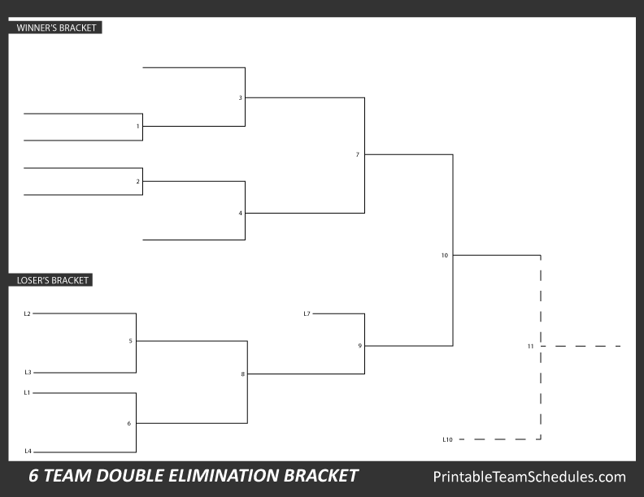

Sat Gm 8

Sat Gm 6

3 Seed

6 Seed

**Sat Gm 10** ***CHAMPIONSHIP***

**Sat Gm 11** ***CHAMPIONSHIP***

*\*If necessary*

**Double Elimination Tournament**

**\*If a team’s first loss occurs in the Championship, a rematch of that game is necessary and Game 11 is utilized**

**Sat Gm 7** ***CHAMPIONSHIP PLAY IN***

Winner advances to Championship

**Sat Gm 9** ***CHAMPIONSHIP PLAY IN***

Loser receives 3rd place

Sat Gm 7

FRI Gm 4

FRI Gm 3

THUR Gm 2

THUR Gm 1

Sat Gm 5

**10U Tournament Bracket**

5 Seed

2 Seed

1 Seed

4 Seed

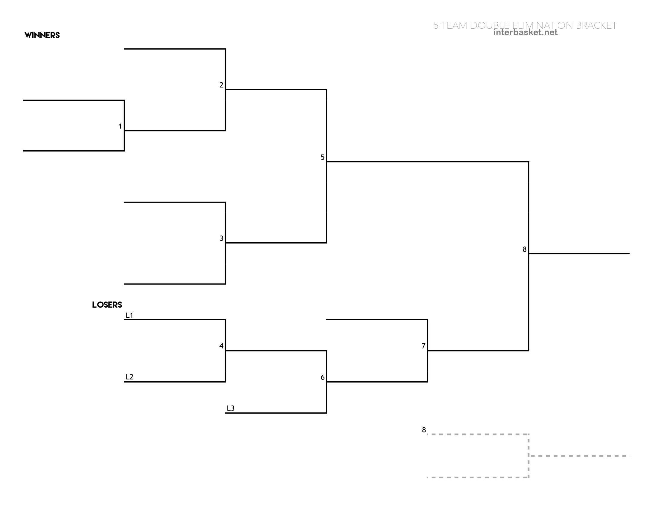

SAT Gm 9

Championship

*\*If necessary*

**SAT Game 8**

**CHAMPIONSHIP**

**10U Tournament Bracket**

**Double Elimination Tournament**

**If a team’s first loss occurs in the Championship, a rematch of that game is necessary and Game 9 is utilized**

**Sat Gm 5** *CHAMPIONSHIP PLAY IN*

Winner advances to Championship

**Sat Gm 7**

*CHAMPIONSHIP PLAY IN*

Loser receives 3rd place

**12U Tournament Bracket**

**10U Tournament Bracket**

SAT Gm 6

SAT Gm 4

TUE Gm 3

WED Gm 2

TUE Gm 1

3 Seed

1 Seed

4 Seed

5 Seed

2 Seed

****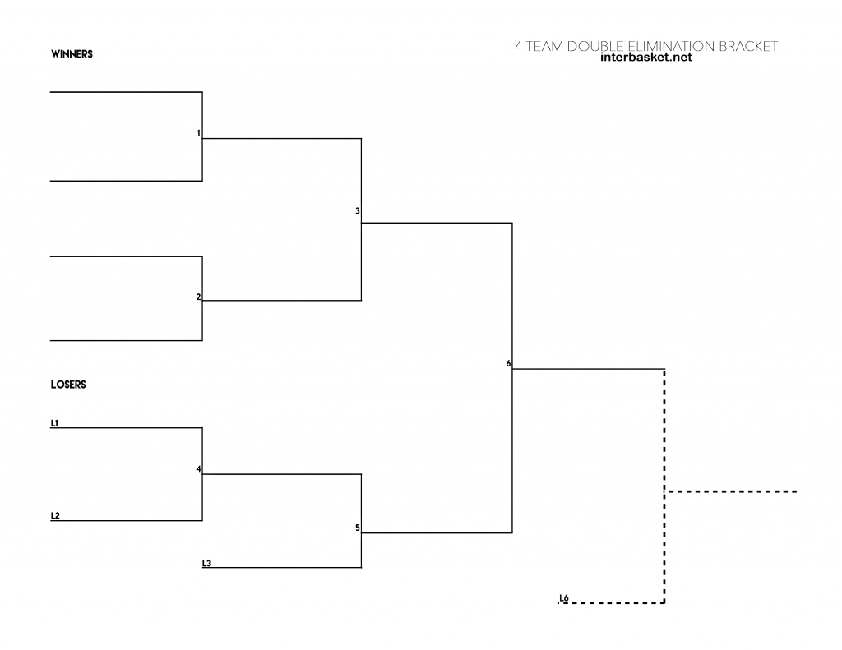

**Game 7**

**CHAMPIONSHIP**

*\*if necessary*

**Game 6**

**CHAMPIONSHIP**

**Game 5**

*Championship Play in*

Loser receives 3rd place

GM 7

GM 4

GM 3

GM 2

GM 1

3 seed

2 seed

4 seed

**Double Elimination Tournament**

**If a team’s first loss occurs in the**

**Championship, a rematch of that game is**

**necessary and Game 7 is utilized**

**Double Elimination Tournament**

**If a team’s first loss occurs in the Championship, a rematch of that game is necessary and Game 9 is utilized**

**14U Tournament Bracket**

**10U Tournament Bracket**

**10U Tournament Bracket**